Hailsham & District Twinning Association
Newsletter No. 10 January 2015

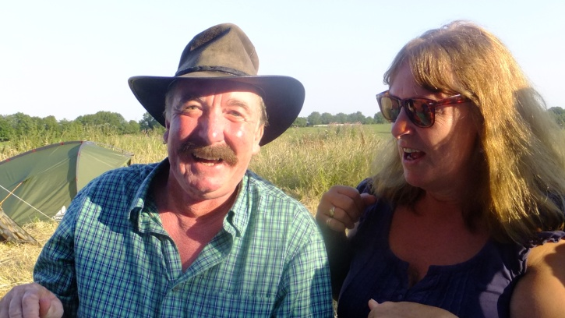
Hello Twinners!
I am writing this newsletter as there is so much information to share with many exciting events lined up for 2015. John Puttick has done a great job with the newsletters previously but unfortunately he has not been too well just recently. We all wish him a speedy recovery and hope he gets the rest he needs to get better soon. All the best John!
Mandy Pittman
Chairman’s New Year Message
A New Year welcome to all our members. We hope that 2015 will be a successful Twinning year and we have already planned many social events and exchanges. We hope these will suit all tastes.
As you know, we are a strong, stand alone, Twinning Group, who are self-financing. Our social events help to maintain our funding levels as well as providing fun and entertainment. Thank you to all for supporting these events by attending and also thank you to the committee for all their continued help. On that note, we have two new committee members: Geoff and Mandy Pittman. We have also attracted two new Twinning members already this year.
Our first new event of the year is a “soiree”, on Saturday 28 February 2015. Last year this proved to be so popular that we decided to run another one. We are pleased to have hired a local band, Memphis Flyers, for the evening. They are a “rockabilly” band and include one of our twinning members, Dave.
I am pleased to announce that we are running several French Groups now (thanks to Pam Smith), and may also have another French teacher available in the near future. We have our conversation group of members who meet regularly and welcome French speakers to come along and practise together. There are two ex-French teachers that attend these sessions, which help to keep everyone on the right track.
Some recent sad news from our French friends who informed us that Marcel Barbotte passed away. He was their vice chair and the person that set up their website and produced their newsletters.
On a happier note, our new Twinning website is now up and running, and will be updated regularly. Find it at www.hailsham-gournay.org.
Best wishes, Keith
EVENTS PLANNED FOR 2015
January – No events planned
28 February 2015
Soiree - to include Rockabilly Band and supper.
Charles Hunt Centre, 7.00pm. Dress code: red, white and blue (i.e. French(. £8.50 per person. Members and friends welcome.
We hope that some of our French friends will be staying with us for this. Please let Pauline know asap, and by MidFebruary at the latest, if you want tickets to help us with numbers for catering.
28 March 2015
Quiz and Supper Evening
Charles Hunt Centre, 7.00pm. £7.50 per person. Teams of 4 to 6
Come as a team or join up with others on the night
18 April 2015
Twinning Games Evening
Charles Hunt Centre, 7.30pm. £5.00 per person
Traditional English games – Toad in the hole, quoits, shove ha’penny
Bring your own drinks but light refreshments will be available
11 to 19 April 2015
Gournay en Bray Art Exhibition, Franco/Anglais Arts
A week long art and craft exhibition in the beautiful new art centre in Gournay. The cultural service in Gournay has kindly invited Hailsham artists to take part, promoting it as a joint English and French exhibition. Geoff will be taking his pottery over and staying for the first weekend and will be taking some samples of other local artists’ works. Some members might like to visit but will need to arrange their own transport and contact Pauline to organise host families to stay with.
21 June 2015
Music Festival at Gournay en Bray
Our local band, “Con Brio” will be playing
Car drivers taking own cars
14 June 2015
Car Treasure Hunt and BBQ
Meet at South Road car park at 1.00pm
£5 per person. Friends welcome
18 to 20 July 2015
Coach visit to St Clair Festival, Gournay en Bray
Hailsham Youth Group will be going. Please let Pauline know if you would like to book a place on the coach. Due to demand, a larger coach has now been hired so there are spaces available – see note from Pauline below.
Other events being planned:
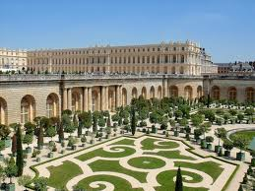
September 6th Walking Treasure Hunt Sunday, 1.30 South Road
Car Park Cream tea to follow. Members and friends welcome.
Also, a possible weekend visit to the Palace of Versailles in France
In October it is hoped that we will be hosting a sporting weekend with youths from our Twinning in France, Germany and England taking part.
In November the choir from Gournay en Bray will be visiting Hailsham, following the successful trip by the Hailsham Choral Society to France last year. They will be singing in a concert with the Hailsham Choral Society at Hailsham Church
In December, each year, Gournay holds it Telthon (like our Children in Need). We would like some English carol singers to participate in this. Please let Pauline know if you are interested. It is hoped that a small group will travel over by car or minibus.
Please note that some of the dates are still to be confirmed when we are able to book the Charles Hunt Hall
Coach trip to St Clair – more details from Pauline:
At present we have a 39 seater coach booked for this event - we are taking over a number of youth from Hailsham, together with their Youth Leaders.
We have 14 Twinning members who have already informed me they want a seat booked and I will be collecting deposits next month.
PLEASE NOTE:
Any members who wish to join in MUST confirm to me in the next two weeks. If we have 10 more members needing seats we will then go ahead and change the coach booking to the larger coach (which brings the cost per person down) - approximately £70 ish for the weekend per person.
Update from AGM
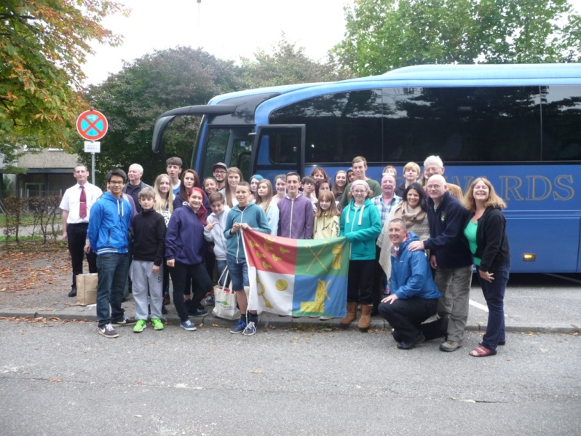
The AGM was held at the Methodist Hall on 28 November 2014 and was well attending with some of the Hailsham Youth Group as well. They gave a very interesting film show and talk following their successful trip to the Remshalden/Gournay en Bray 25yr celebrations. It was clear that they had a great time, and have made many good friends with their peers in France and Germany. The committee was voted back in with Mandy and Geoff Pittman being co-opted as extra committee members.
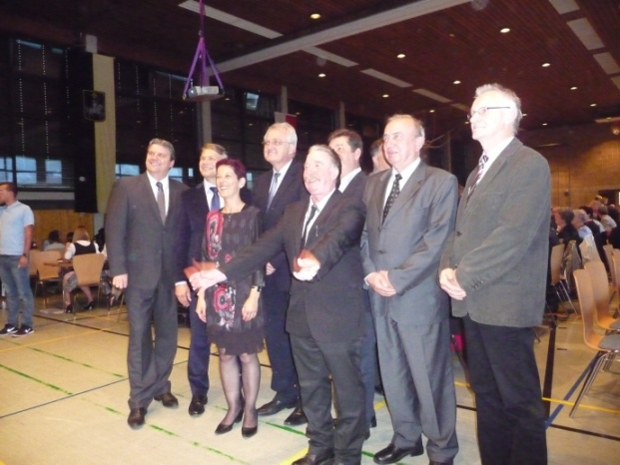
German Twinning Trip
As reported before, this visit to join in the celebrations of 25 years of twinning between Gournay and Remshalden, was very successful. Inviting us to join in helped to extend the ethos of twinning further, promoting wider friendship with our fellow Europeans. It was agreed by all who went, including the 22 youths and their leaders, that it had been a fantastic weekend. It involved a fifteen hour coach journey but the youngsters did us proud acting as good ambassadors for their country and sharing in the home life of their host families. They joined in all the activities with the right spirit of fraternity and some have made lasting friendships as a result. A grand civic meal was provided with speeches from all the dignities. Keith’s speech avoided the rather political tone of the others, talking about the importance of twinning and the friendships it promotes instead. Other activities enjoyed during the stay included visits to factories, a vineyard tour and wine celebration.
Do you want to learn to speak French? Do you speak a bit of French but want to practise, or improve?
Pam Smith, our membership secretary and ex-French teacher, gives lessons to beginners and assists with the conversation sessions for those ready to move on. Pam currently runs three groups for the twinning association, which are in addition to her private and U3A classes. They are on Tuesday evenings and Wednesdays during the day, £2 per person, with £1 towards twinning funds. The conversation sessions are due to start again soon in late January and are held fortnightly on a Monday evening, £2 per person all towards twinning funds . If you are interested in joining any of these groups please contact Pam for the lessons on 01323 442151 or Pauline on 01323 846539.
Also, Sandra Wade, another twinning member, is available to provide extra French lessons if anyone is interested. She is already working with Geoff and Mandy to improve their rather basic French conversation. Geoff and Mandy would be very happy for others to join them at their home for these sessions, or Sandra would consider setting up new groups, subject to interest. Cost would £5 for a 1¼hr session with £1 of this going towards twinning funds. Please contact Sandra if you are interested on 01323 440669 or 07962 625927.
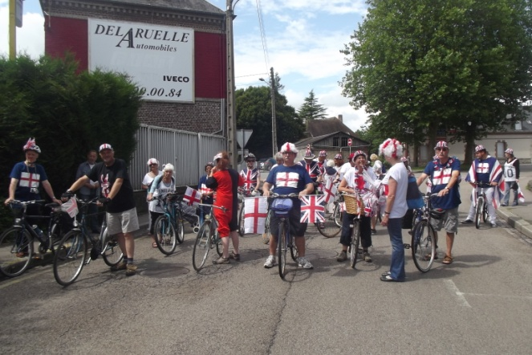
CYCLING UPDATE – by Mandy
On Friday 9 January the Twinning cyclists had a reunion at Geoff and Mandy’s place, and Ed came too. Fourteen of the cyclists that went to Gournay in July 2014 (plus Ed) enjoyed a film show compilation of photos taken during the trip. Photos were taken by Zoe, Mary, Ralph, Geoff and Mandy. The film show had previously been shown at the AGM but it was good to see it on a big TV. Everyone then tucked into a take away curry feast, managing to all squeeze round our dining table, specially extended to seat us all. It was a lively fun evening with some discussions of future plans.
The cycling group meets for a local cycle ride on the first Saturday of the month, under the railway bridge in South Road Car Park at noon. Led by Ralph, it is decided whether to go north or south, up or down the cuckoo trail and round the quieter roads. Hailsham is well served for cycle routes so there is a good choice and includes a stop somewhere for refreshments. If you would like to join in please contact Mandy or Geoff on 01323 440168, or email Geoff@pittman.co.uk (see contact details at end of newsletter) so we can pass your details on to Ralph, or just turn up on the day.
The cycling trip to Gournay was great fun and it is hoped to organise another one next year, maybe at a different time of year. It is also hoped to organise some other cycling trips further afield this year, possibly even abroad, but this would be arranged as a separate event from the Twinning Association. If anyone new is interested in joining in the Gournay trip in 2016 then please contact Geoff or Mandy to be included in the group. You would need to be a fully paid up Twinning member for this.
Christmas Meal December 2014
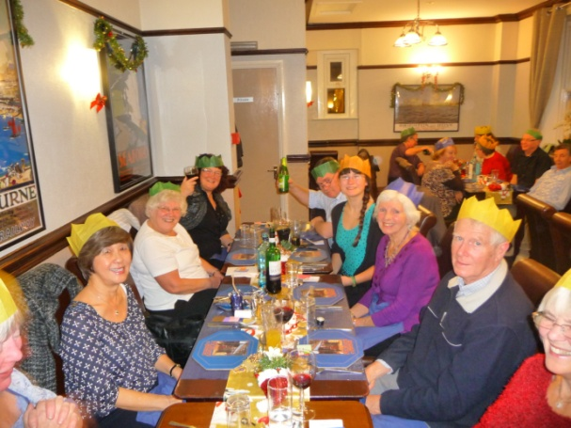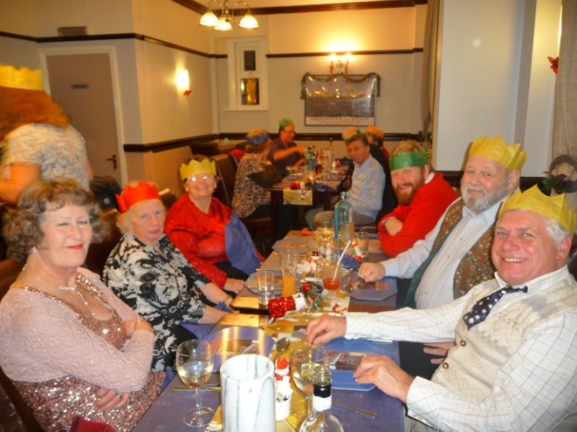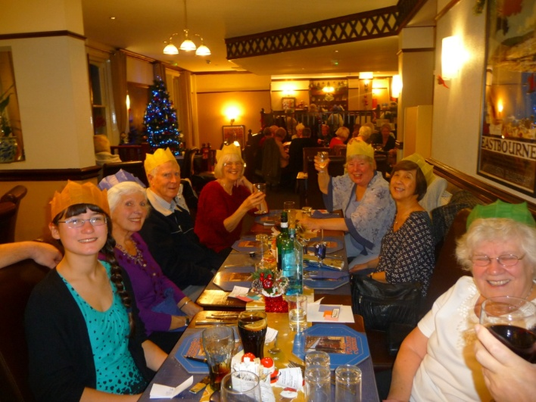
Hailsham Twinning Committee:
Keith Townsend Chair 01323 846539
John Puttick Vice Chair 01323 449352
Pauline Townsend Secretary 01323 846539
Nicola Stone Treasurer 01323 842660
Pam Smith Membership Secretary 01323 442151
Paula Rose Social Secretary 01323 841373
Other committee:
Liz Jones 07446 961969 Alan Stone 01323 842660
Sharon Cottinghan 01323 845792 Katy Layer 01323 843125
Ian Haffenden 07880773125 Mandy Pittman 01323 440168
Geoff Pittman 01323 440168

