Hailsham & District Twinning Association

Newsletter No. 11 June 2015

A WORD FROM THE CHAIRMAN

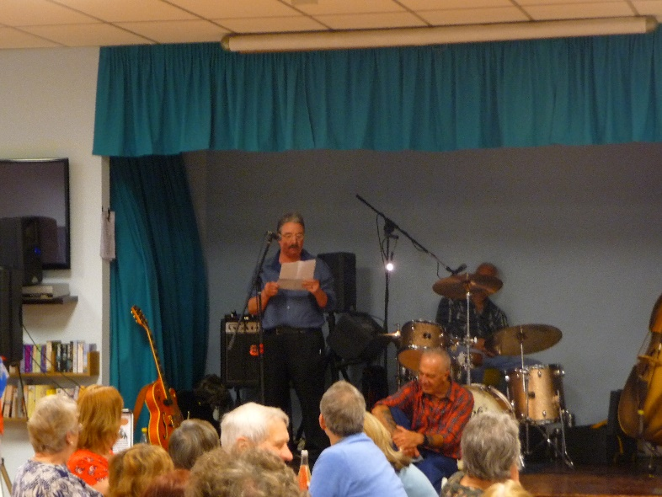Well hello again. Here we are nearly half way through the year and heading into “holiday season”. How about a holiday in France? In particular a visit to our twinned town, Gournay en Bray?

As you are aware, during each year we organise various trips to Gournay – it’s in a lovely region , with Rouen just around the corner, Forges Les Eaux nearby, and with Paris within easy reach.

Talking of Paris – we are setting up a visit to Gournay and to the Palace of Versailles over the weekend of 5-7 September – this will provide a great opportunity for sightseeing.(An opportunity not to be missed) We are investigating mini bus hire costs for this trip. Our trips are all on a shared costs basis, everyone pays the same amount including me!

Do you want to join in this trip? Not sure? Contact us and find out more. Here are some questions and answers.

Do you have to speak French? – no, not at all. A number of our members cannot speak French, some have chosen to learn or relearn.

Do I have to stay with French hosts? – It is nice to and we have found that you learn about real French life but you do not have to as there are hotels in Gournay.

Do I have to host French guests when they visit Hailsham? No, not if you do not want to. Again, we have found that so many friendships are formed by doing so.

Why do I do it? I have made many friends in Hailsham and Gournay since joining the Twinning Association and I enjoy the social side and the events. I have also started French lessons too – Monsiour Le Bluffer!

Most of all, I get great enjoyment out of seeing so many people enjoying what the Association offers and having a wonderful time with their English and French friends.

May I remind everyone that we are having a visit from the Gournay Choir again – 26th September where they will join the Hailsham Choral Society for a concert in Hailsham Church.

We also have two cycling events coming up up, one in June and one in August. This consists of some French cyclists visiting the Hailsham area and requiring hosting and also wanting to join up with our Hailsham Twinning cyclists too.  
  
We are going to host a Youth Event for French youth to stay with host families and to meet with English youth over the weekend of October 23-26th. Our Association will be organising some day and evening events for them too.

One last thing, myself and the committee would really like to hear from anyone who has not, for any reason, visited our twinned town. Suggestions for future exchanges and ideas for new social events are always welcome.

Bonne Chance, *Keith*

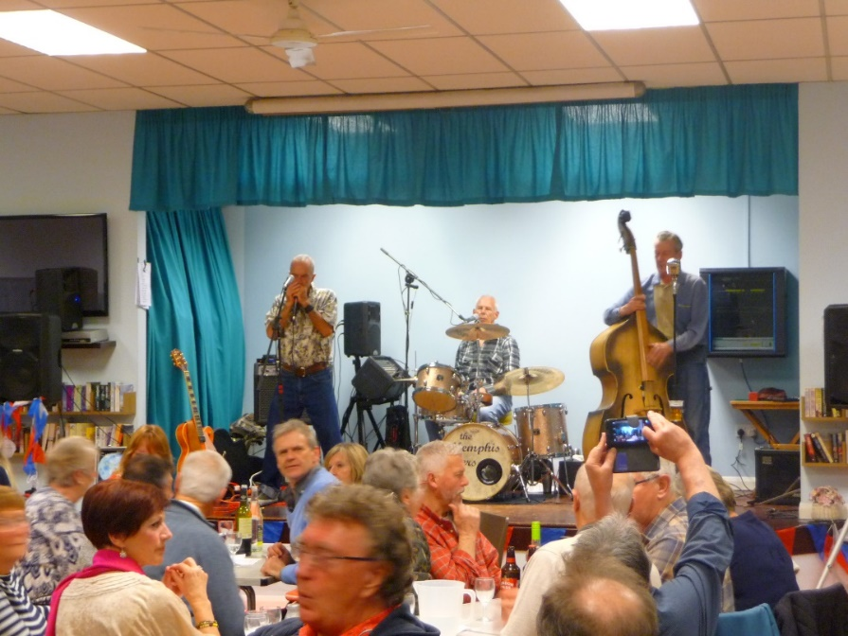**Events enjoyed so far this year:**

On 28 February we held a “**Soiree**” following on from the success of one last year. This was well attended again with singing and dancing to the live band Memphis Flyers accompanied by our very own twinning member Dave Taylor. A group of several 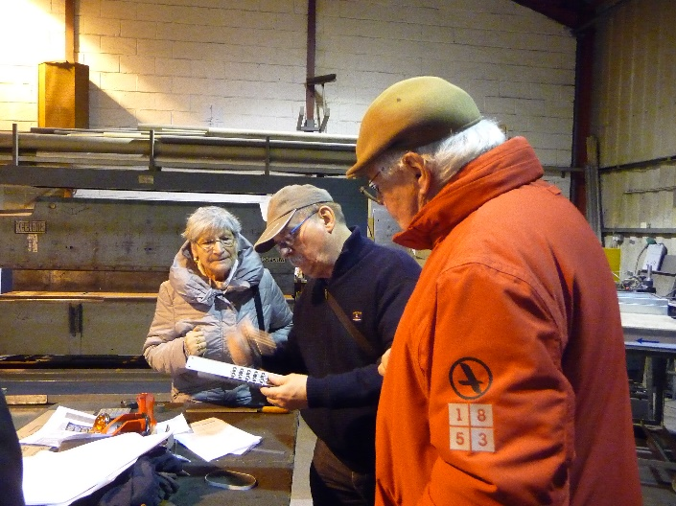Gournay friends came over for this. Paula did a grand buffet meal with members donating some food and there was a fun table quiz with French and 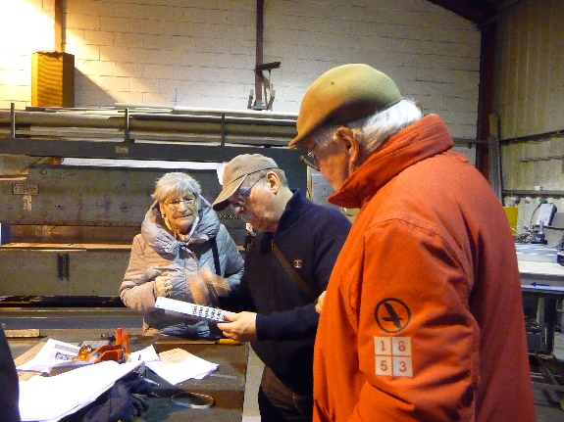English questions, which went down well. It is hoped to hold this again next year.

During the weekend Alan Stone kindly gave a tour of his factory down on the Diplocks Industrial Estate to a small group of the French.

In March we had another of our popular **quizzes** with John again as quizmaster. This continues to grow in popularity with tickets selling out, and two teams of twinners from Polegate joining in the fun with us. Team Hailsham FM were the winners.

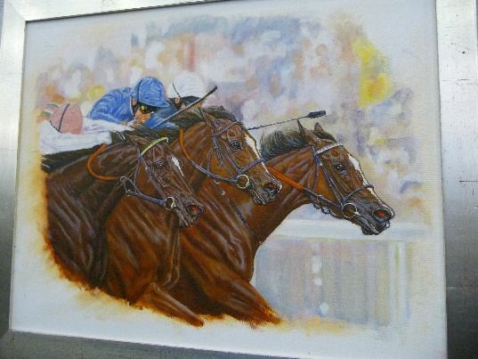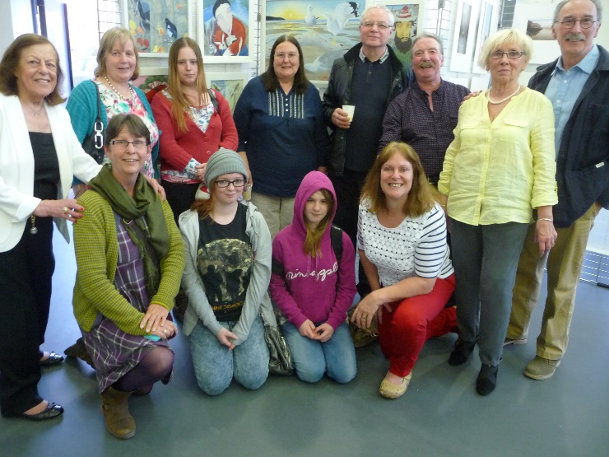In April, Gournay held a second “**Exposition Artistique**” at their impressive l’Atelier in the town, showcasing both English and French art work. Geoff Pittman (potter) and Nicola Stone (photography) had both showed their work two years before, but this time there were thirteen English artists joining in. Alice Plowman and her daughter, Susannah, travelled over to spend the opening weekend at Gournay, along with Nicola and Geoff. Sharon Cottingham contributed some paintings. Several artists were new to the twinning and joined as members in order to take part, taking our membership up to 70 in total. Artwork included paintings, quilting, photographs and pottery. Dennis Narine (*see his picture left*) won the prize for best painter, Nicola won best photographer and several other prizes were awarded. The exhibition was on for a week and Paul and Mary Simmons travelled over the second weekend to help bring all the artwork back, so a good team approach. As always the 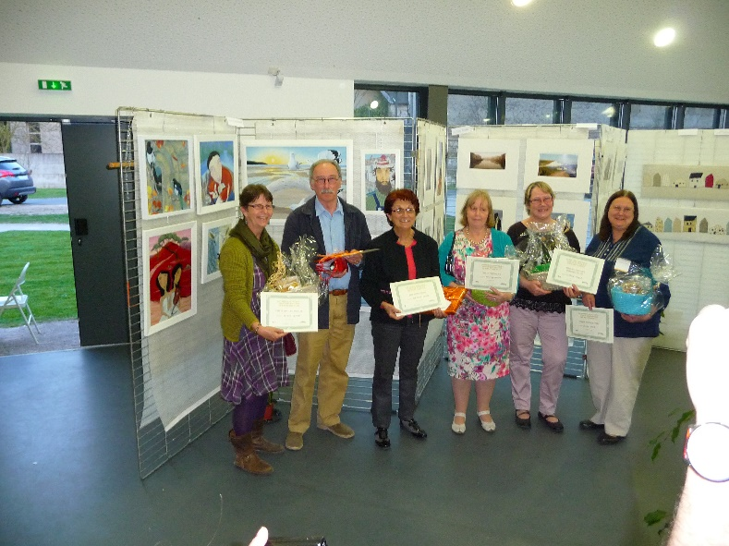English visitors were well looked after by very hospitable hosts, staying with French families in their homes and meeting up for a meal one evening.

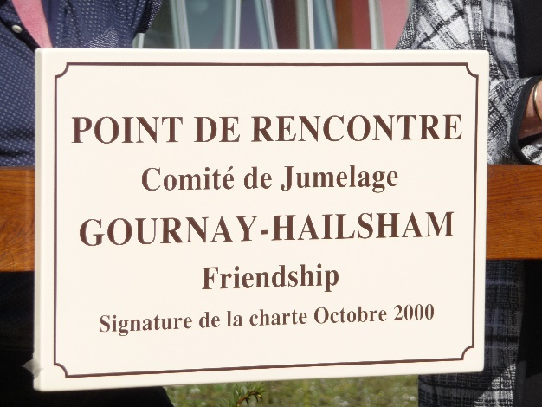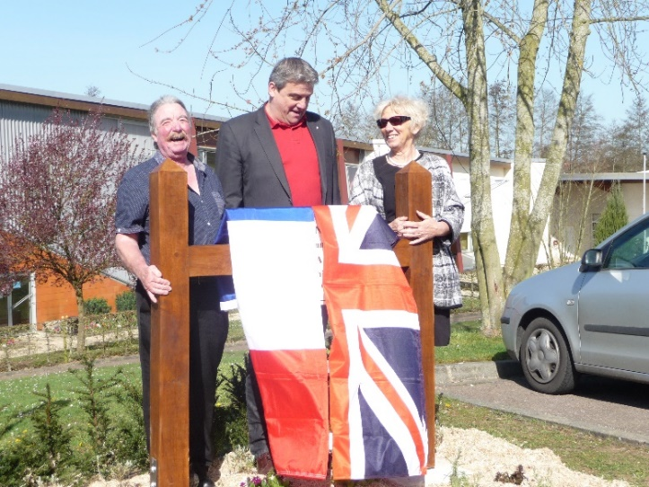Whilst the art exhibition was going on there was another important twinning event in the town, the unveiling of a new plaque to mark the meeting point for English and French twinning members. Over the years it has become a tradition to meet our French friends in the local swimming pool car park whenever we visit Gournay. The mayor of Gournay, Eric Pickard, unveiled the plaque and several speeches were made by the mayor, and both twinning chairs. The plaque is in addition to the official “Rue de Hailsham” in the town. In Hailsham we have the equivalent, Gournay Road off Hempstead Lane

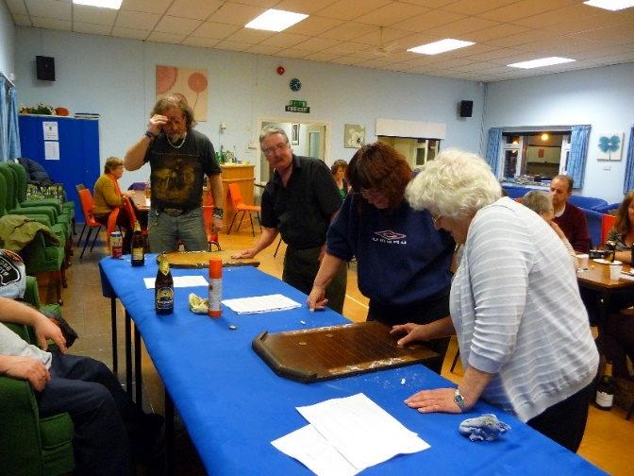

In April we tried a new event, a **games evening**. The idea was a social evening with traditional games such as Toad in the Hole, Shove ha’penny, dominoes, skittles, cards etc. Alan very kindly made a Toad in the Hole which was very popular. Inventive as always, here he explains:

*The Challenge*

*Well my challenge anyway. You get an old bedside cabinet. Take off its door and top. Then make a tray complete with a hole and put this on top. Voila! I have a Toad in the Hole!*

*This came about only because I could not buy one anywhere. And I did say I would get one. So off to the pub games evening. Success it was OK. But I must be the worst player of Toad in the Hole. Hats off to Dave Cottingham who won the competition. I did enjoy our firs games evening. Many thanks to all who organised and took part. A most enjoyable evening*

*Regards, Alan.*

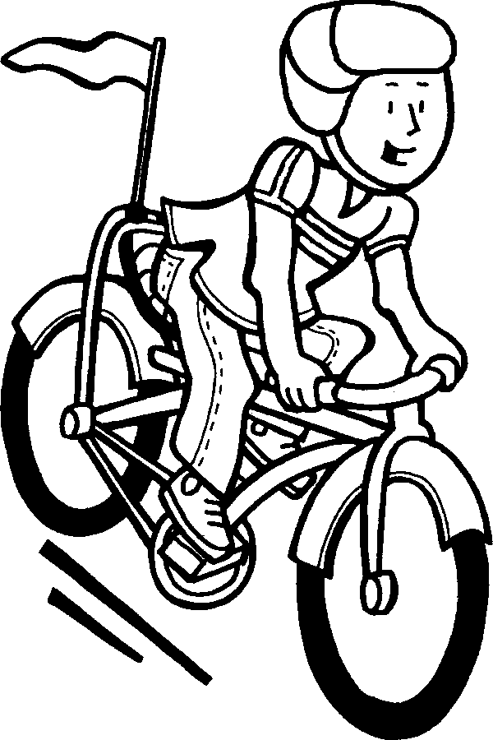

Cycling News

The cycling group has been enjoying monthly rides on the first Saturday of each month. So far they have enjoyed trips to Lakeside Café at Horam, Chilly Farm, Arlington Tea Rooms, Old Loom Mill, The Cuckoo Shack and the Upper Dicker Shop/café. The rides are leisurely - no racing or lycra - and avoid main roads where possible, and as you can tell they always include a stop off for refreshments! The Dicker café, in particular, has been a grand find. Wonderful atmosphere and good home cooked food – a hidden gem in Sussex!

****During the winter the rides commenced at midday with a lunch stop but it was then decided to try an earlier start at 9am with a stop for breakfast instead. It was felt that this would not then take up the whole day but rather leave time in the afternoon for other activities or chores. This will be reviewed over the summer pending suggestions for other timings or perhaps riding on a Sunday. Janet has even purchased an E-bike to help power her up the hills with her inaugural ride on 6th June! Ralph and Janet will be looking to sell their tandem and Janet’s bike at some point. Any interest with this please contact them direct, if you have their contact details, or phone committee members, Geoff or Mandy Pittman who can pass on a message. If anyone is interested in joining us please contact a committee member.

A group of French cyclists (serious ones this time), led by the Gournay ex Twinning Chair, are due to cycle from the south of France via Paris, Gournay, Dieppe, Hailsham and London. Hosts have been arranged for them to stay one night when they get to Hailsham on 4th June before they continue on their long journey.

In August sixteen cyclists, plus transport support vehicles, are planning to cycle from Forges les Eaux to England, staying in a youth hostel near Lewes. They intend to cycle from Lewes to Hailsham and then to Eastbourne during their stay here on 30th August. The next day they plan to cycle to Newhaven via Hailsham before catching their ferry back to Dieppe at 5.30pm. They would really like it if some of us joined them for a cycle on either of these days. Paul Simmons will be coordinating times but if you are interested please let committee members, Geoff or Mandy know.

It is hoped to make a return trip to France in 2016, staying in B&B or camping again. Dates and arrangements to be made soon – watch this space!

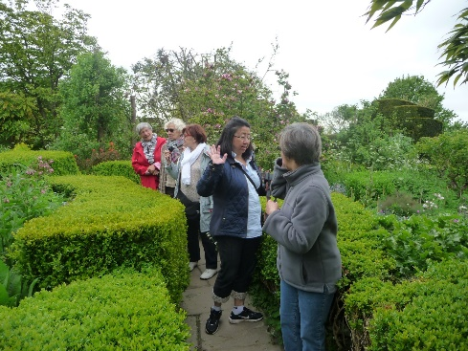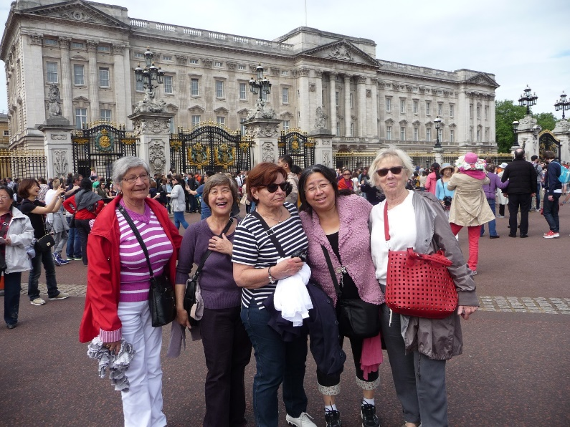In May an impromptu visit was made to Hailsham by a group of ladies from Gournay. Annick, Claudine, Regine and Wai Lin stayed with their regular host families for the weekend. The group and their hosts met up on Saturday to go to Great Dixter to see the beautiful house and garden with a stop off on the way home to have tea at the Lime Cross Nursery. In the evening, after a meal with their hosts, they all met up at the White Hart in Horsebridge to enjoy an evening’s live entertainment by an acoustic duo. On Sunday they all went to London for a sightseeing day. A busy but enjoyable extra trip with lovely weather.

In fact these extra trips are quite common. After a few exchange trips members often find that they form firm friendships with their hosts. In fact Geoff and Mandy welcomed Annie, Thierry and some of their family, to stay with them for a short holiday last October. That is the wonderful thing about Twinning. You really get to meet some lovely people and build close bonds, sharing home and cultures with each other. You never get that staying in hotels on your holidays!

**And more to come:**

**18-20 July 2015** the next trip to Gournay will be in July for the St Clair Festival. The coach is fully booked and, as is the tradition, members will participate in the carnival weekend.

**August Bank Holiday** European street market in Hailsham. French twinners bringing over produce to sell at our Twinning stall. A group of French cyclists also due this weekend. Hosts **needed.**

**5-7 September 2015** Visit to Versailles. Possible mini-bus being hired.

**26 September 2015** Gournay choir visit to Hailsham. May need some hosts.

**23-26 Ocober 2015** Youth visit to Hailsham. Events over the weekend to be organised. Hosts needed

**Walking Treasure Hunt** – date to be rearranged.

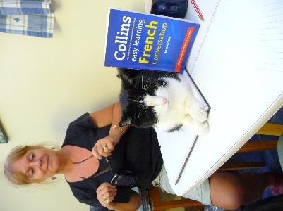

**Obituary:  
Ferdie the cat**Owned by twin membership secretary, Pam Smith, Ferdie enjoyed joining in the French lessons at Pam’s house. Sadly she passed away recently. A dearly loved pet – sadly missed.

**Hailsham Twinning Committee:**

Keith Townsend Chair 01323 846539  
John Puttick Vice Chair 01323 449352  
Pauline Townsend Secretary 01323 846539  
Nicola Stone Treasurer 01323 842660  
Pam Smith Membership Secretary 01323 442151  
Paula Rose Social Secretary 01323 841373  
  
**Other committee:**Liz Jones 07446 961969   
Alan Stone 01323 842660  
Sharon Cottinghan 01323 845792   
Katy Layer 01323 843125  
Ian Haffenden 07880773125   
Mandy Pittman 01323 440168  
Geoff Pittman 01323 440168